**General Human Biology**

**Year 11**

**Task 7: DNA & Reproductive system**

**Weighting 10%**

**Name: Total: ____/52**

**%**

**Multiple Choice Section 10 marks**

1. Mitosis is a cellular process, which correctly lists the characteristics of this process.
   1. DNA replicated, chromosomes are split, cell divides into 2 daughter cells
   2. DNA replicated, chromosomes line up on equator, chromosomes are split, cell divides into 2 daughter cells
   3. DNA is replicated, chromosomes line up, chromosomes are split, cell divides twice into 4 daughter cells
   4. DNA replicated, chromosomes are split, cell divides into 4 daughter cells
2. Meiosis creates gametes, which correctly lists the characteristics of the female daughter cells
   1. Doesn’t contain organelles, 23 chromosomes, large, produced in ovary
   2. Contains organelles, 23 chromosomes, small, produced in ovary
   3. Contains organelles, 23 Chromosomes, large, produced in ovary
   4. Contains organelles, 23 pairs of chromosomes, large, produced in ovary
3. FSH is responsible for
   1. Ovulation
   2. Shedding endometrium
   3. Beginning menstrual cycle
   4. Developing ovum
4. Which correctly lists the steps in the production of semen
   1. Spermatid develop in testes, become mobile in the epididymis, move through vas deferens, seminal vessel, prostate and urethra
   2. Spermatid develop in epididymis, become mobile in the testes, move through vas deferens, seminal vessel, prostate and ureter
   3. Spermatozoa develop in testes, become mobile in the epididymis, move through vas deferens, seminal vessel, prostate and urethra
   4. Spermatozoa develop in testes, become mobile in the epididymis, move through vas deferens, seminal vessel, prostate and ureter
5. Which part of the male reproductive system is responsible for the production of testosterone
   1. Testes
   2. Epididymis
   3. Prostate Gland
   4. Seminal Vessel
6. What process results in an unexpected allele being passed down to offspring
   1. Cross- over
   2. Independent assortment
   3. Random fertilisation
   4. Mutation
7. Progesterone is a hormone in females responsible for:
   1. Ovulation
   2. Shedding the endometrium
   3. Developing ovum
   4. Fertilisation
8. Which correctly lists the stages of sperm production
   1. Spermatid- spermatozoa- semen
   2. Spermatozoa- spermatid-semen
   3. Sperm- spermatid-spermatozoa- semen
   4. Spermatid-sperm-spermatozoa-semen
9. Polar bodies are found in female ovaries, which correctly explains why
   1. Error during meiosis
   2. Unequal division during meiosis
   3. Lack of LH
   4. Lack of FSH
10. Which correctly identifies when production of gametes starts and stops
    1. Males start at puberty and stop at menopause
    2. Females are born with eggs and end at death
    3. Males start at birth and end at death
    4. Females are born with eggs and end at menopause

**END OF MULTIPLE CHOICE**

**Short Answer Section 42 marks**

**Question 11 7 marks**

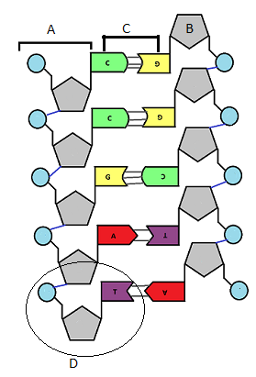

1. What structure is labelled D (1 mark)

1. What structure is labelled C (1 mark)

1. Explain the difference between a gene and an allele, use an example to support your answer (2 marks)

1. Explain the purpose of DNA in the human body (3 marks)

**Question 12 8 marks**

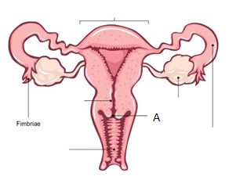

1. Label the structure that is shed during menstruation (1 mark)
2. Label the structure responsible for sperm sorting (1 mark)
3. What are two of the functions of structure labelled A (2 marks)

1. Fertilisation and implantation result in a pregnancy, if this does not occur explain what hormones are responsible for the next menstrual cycle. (4 marks)

**Question 13 9 marks**

1. What is the difference between the vas deferens and the urethra (3 marks)

1. People often say that the male reproductive system is designed to fertilise eggs but the female reproductive system is designed to kill sperm. Explain this statement. (6 marks)

**Question 14 6 marks**

1. Using the terms N and 2N explain the difference between mitosis and Meiosis (3 marks)

1. Some plants reproduce asexually, what type of cell division is used and explain what impact this has on the offspring. (3 marks)

**Question 15 7 marks**

The punnet square below has been used to predict if a child will have a hitchhikers thumb.

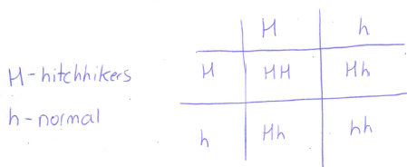

1. Is this trait Dominant or recessive (1 mark)

1. If two parents without a hitchhikers thumb have a child can their offspring have one? Use a punnet square to support your answer (3 marks)

1. In Miss Roberts’ garden she has Red and White flowers, however, one day she found a orange flower growing. Explain how this happened (3 marks)

**Question 16 5 marks**

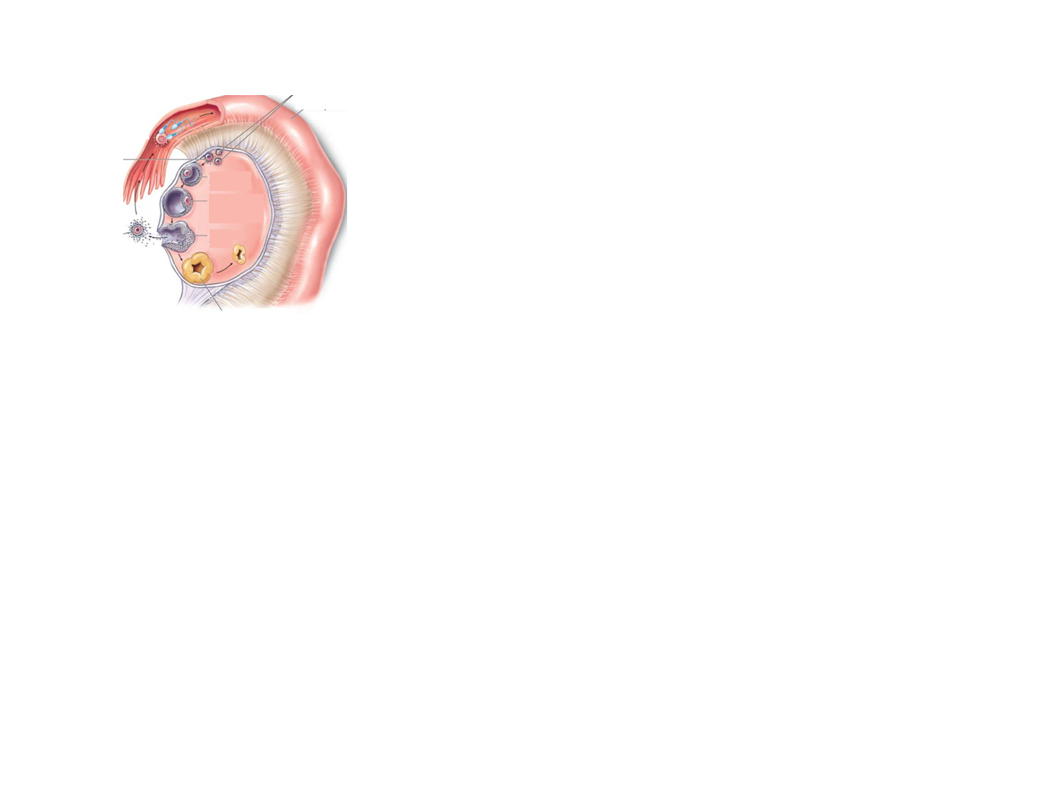

1. Using the diagram above, explain ovulation